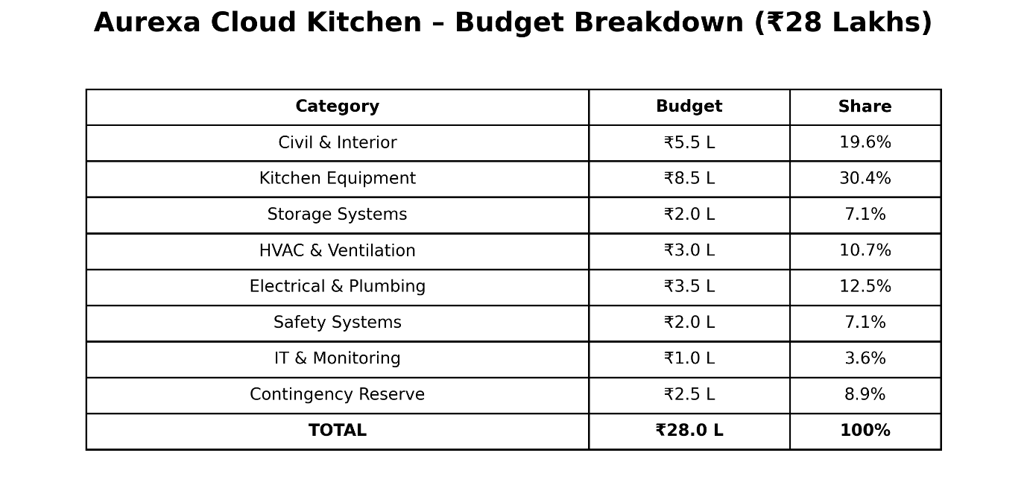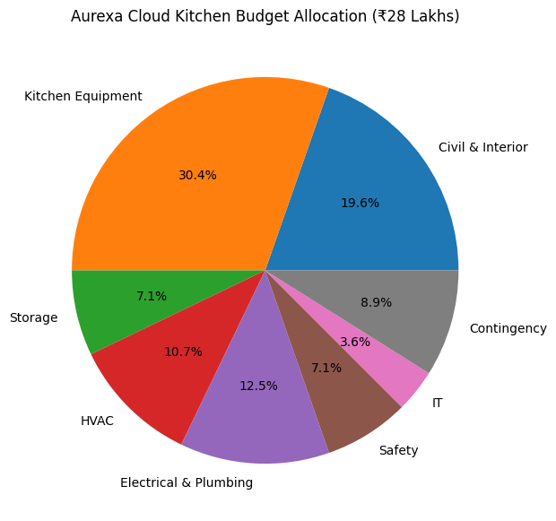

Slide 3 – Cost Optimization & Risk Analysis
Title:
Cost Optimization & Risk Management
Left Side: Cost Optimization
✅ Bulk Procurement of Materials
✅ Energy-Efficient Equipment
✅ Third-Party Delivery Integration
✅ In-House Bread Manufacturing
✅ Modular Kitchen Layout
Right Side: Risk Management
⚠ Material Cost Increase → Early Procurement
⚠ Equipment Delivery Delay → Multiple Vendors
⚠ Budget Overrun → ₹2.5 Lakh Contingency Fund
⚠ Regulatory Delays → Early Documentation
Bottom Line
Expected Operational Cost Reduction: 10–15% annually
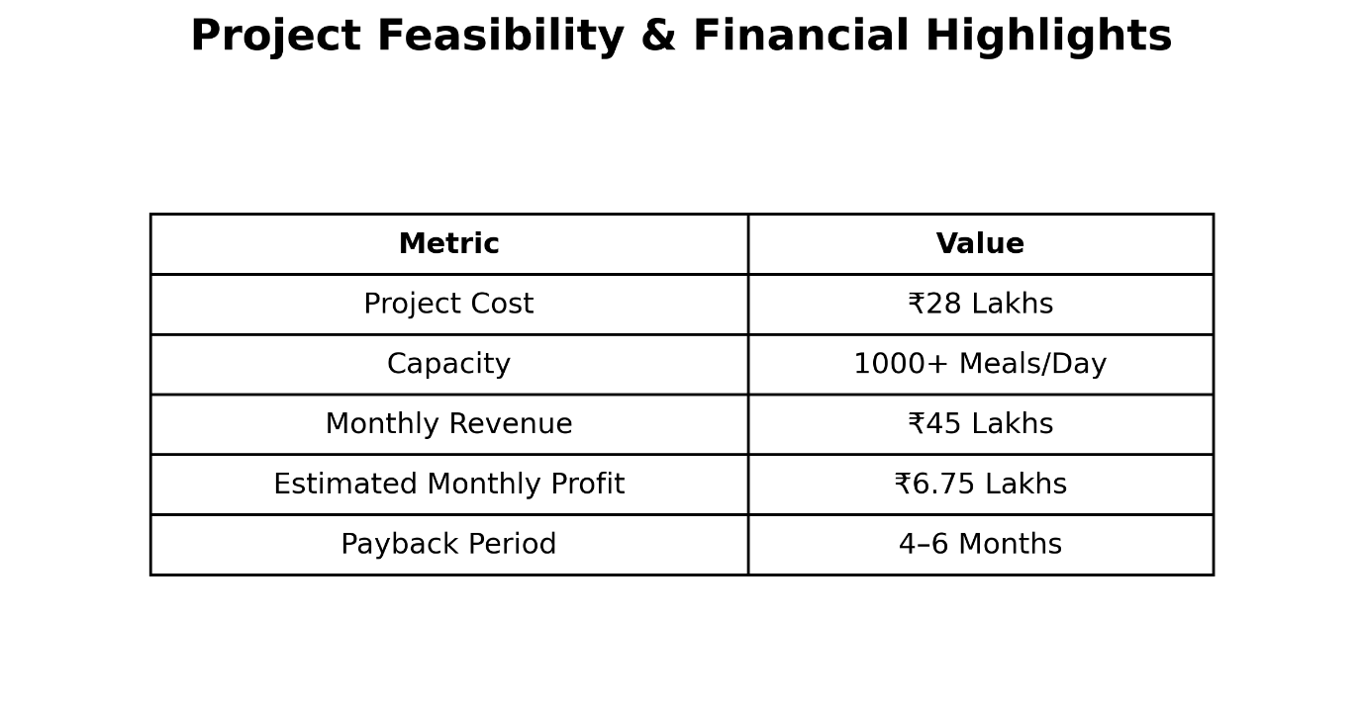
Recommendation
✔ Within Client Budget
✔ Supports 24×7 Operations
✔ Meets Safety & Hygiene Requirements
✔ Strong Return on Investment
✔ Completion Target: 3 Months
Final Statement
"Aurexa recommends proceeding with the proposed financial plan as it ensures operational efficiency, safety, hygiene, and long-term financial sustainability."

Yukta — YUK-tuh
Sanskrit-inspired; associated with being connected, joined, or well-equipped.
Tagline: Smartly Connected.

Anvexa
Inspired by Anvaya (connection) + a modern tech-style ending
Tagline: Connected by Intelligence.
A premium name for a company integrating AI, cloud platforms, and business systems.
Yukti Labs
Yukti means ingenuity or a skilful method
Tagline: Smart Solutions. Real Results.
Indian in meaning, modern in presentation, and especially suited to a problem-solving technology business.

Mandatory points to cover
- Revenue model — How the company earns money.
- Current financial position — Revenue, expenses, profit, and cash flow.
- Funding requirement — How much investment you need and why.
- Utilization of funds — Where every rupee of investment will be spent.
- Financial projections — Expected revenue, expenses, and profits for the next 3 years.
- Profitability and break-even — When the company expects to cover its costs.
- Investor benefits — Equity, potential returns, dividends, and growth opportunities.
- Risk management — How you will handle losses, delayed payments, and unexpected expenses.
- Financial transparency — Regular reports, budgeting, and accountability.
- Unique points to stand out from the other 3 teams
- These are the points I'd prioritize to make your finance pitch more impressive.
- 1. Investor Money Protection Plan
- Set aside a defined contingency reserve and release funds in stages against measurable milestones. This demonstrates financial discipline.
- 2. Three-Scenario Financial Forecast
- Present optimistic, realistic, and worst-case projections. Show investors that you have a plan even if business growth is slower than expected.
- 3. Cash Runway Guarantee?
- Calculate how many months the company can survive using its available cash. Commit to monitoring runway and taking corrective action if it falls below a defined threshold—without promising a guaranteed outcome.
- 4. Milestone-Based Investment
- Allocate funding in phases based on targets such as product launch, client acquisition, and recurring revenue growth instead of spending the entire amount without checkpoints.
- 5. Financial Transparency Dashboard
- Offer investors a periodic dashboard showing revenue, expenses, cash balance, project margins, and progress against targets.
- 6. Client Profitability Analysis
- Show that you measure which projects and clients generate the highest margins, so growth focuses on profitable business rather than revenue alone.

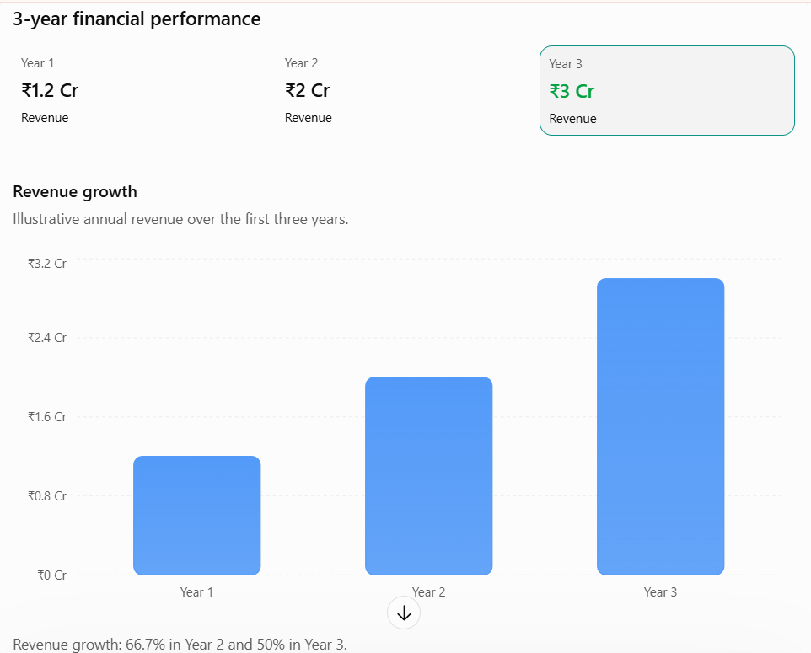
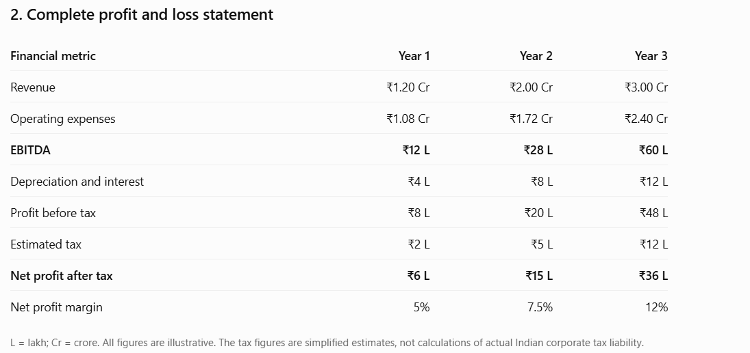
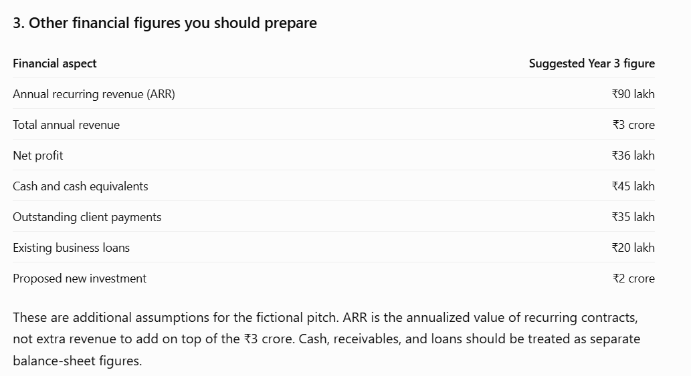
4. How much funding should you ask for?
My recommendation is to ask for ₹2 crore in exchange for a negotiated equity stake.
Before promising a percentage, your team should decide on a defensible company valuation.
For example, if you propose a ₹10 crore pre-money valuation, a ₹2 crore equity investment would imply:
- Pre-money valuation: ₹10 crore
- Investment: ₹2 crore
- Post-money valuation: ₹12 crore
- Investor ownership: approximately 16.67%
This is a proposed valuation example, not a claim that Nexora is actually worth ₹10 crore.

